1. **Do Cropping, Copying and pasting image inside another image using OpenCV**

**Aim:**

To perform cropping, copying and pasting an image inside another image using opencv.

**Code:**

import cv2

import numpy as np

image = cv2.imread(r"C:\Users\prith\Documents\CV\cvimage.jpg")

img2 = cv2.imread(r"C:\Users\prith\Documents\CV\cvimage.jpg")

print(image.shape)

cv2.imshow("Original Image", image)

imageCopy = image.copy()

cv2.circle(imageCopy, (100, 100), 30, (255, 0, 0), -1)

cv2.imshow("Original Image", image)

cv2.imshow("Image with Circle", imageCopy)

cropped_image = image[80:280, 150:330]

cv2.imshow("Cropped Image", cropped_image)

cv2.imwrite("Cropped Image.jpg", cropped_image)

dst = cv2.addWeighted(image, 0.5, img2, 0.7, 0)

img_arr = np.hstack((image, img2))

cv2.imshow("Image Pair", img_arr)

cv2.imshow("Weighted Image", dst)

cv2.waitKey(0)

cv2.destroyAllWindows()

**Input:**

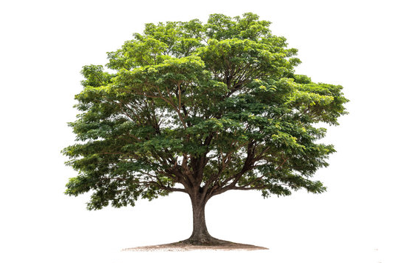

**Output:**

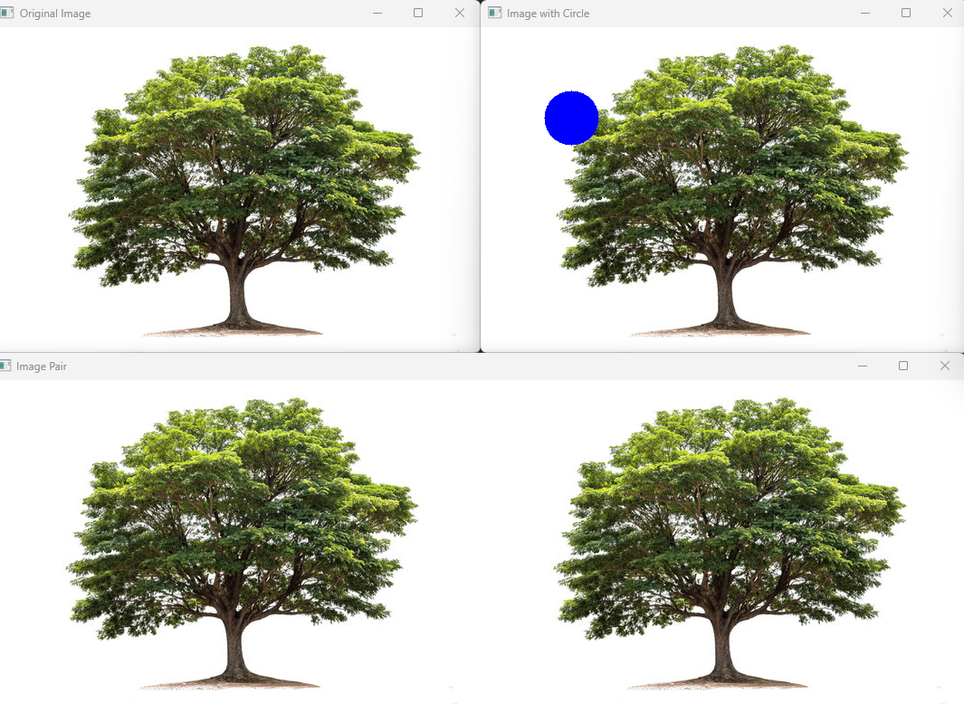

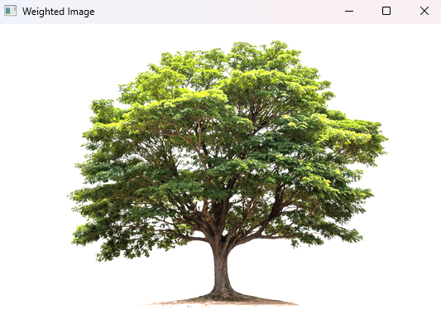

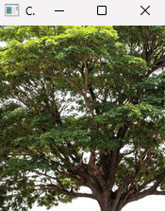

**Result:**

The python code to perform cropping, copying and pasting an image inside another image using opencv has been executed successfully.